Math Mania 2023 - Final Review Handout

Module 1:

1. Compute the following by converting them into signed binary (two’s complement) and convert the solution to decimal and hexadecimal equivalents (All given values are in decimal).
   1. 45 + (-29)
   2. (-121) + (-19)
   3. 207 + 97
   4. (-156) + 141
2. Evaluate the truth value of the following:
3. $∼\left(X+Y\right) ⊕∼\left(X⋅Y\right)→X⋅Y$ where X = 0, Y = 1
4. $P⋅Q ⊕ R ↔ P⋅Q+Q⋅R+R⋅R$ where P = 0, Q = 1, R = 0
5. $A+B⋅C → ∼A+A ↔ 1$ where A = 0, B = 0, C = 0

1. Simplify the following using the Identities and Laws of Boolean Algebra. List the specific laws used for each simplification.
2. $\overline{BA}+B$, Verify this simplification with a truth table

$\overline{\left(\overline{A}⋅B\right)}\left(A+B\right)\overline{A}$

$XY+\overline{\left(XY\right)}+\left(X\overline{X}+X\right)$

$\overline{\left(\overline{A}+\overline{B}\right)}⋅\left(\left(\overline{A}+\left(\overline{A}⋅B\right)\right)+A\right)+\left(ABC⋅A\overline{B}C\right)$

1. A house has an alarm system as follows where switches control the on/off states:

* Switch P arms the alarm system
* Switch Q controls the window alarms
* Switch R controls the door alarms
* Switch S controls the gate alarms

The alarm goes off only if the system is armed and at least one of the other alarms is switched on.

1. Construct a truth table to represent the system
2. Express the sum of products of this system
3. Construct a K-map for the system and use it to simplify the sum of product expression.
4. Constrict a logic circuit to represent the simplified expression

Module 2:

1. Find the Domain and Range of the following functions.
$f\left(x\right)= \sqrt{\frac{3}{4}+3x}+7$

$g\left(x\right)= \frac{2}{1+\frac{x}{4}}-2$

2. In a survey of college students 270 program in C, 750 in Java, and 80 in Python. Of those students, 100 of them program in both C and Java, 60 in both C and Python, and 20 in Python and Java. Only 6 of them program in all three languages.
   1. How many students program in only one single language?
   2. How many students were surveyed?
3. List the first three terms in the following sequences:
$a_{n}= \frac{\left(n-3\right)\left(n+3\right)}{3n^{2}+2n+1}, n≥0$

$b_{n}= 2^{n+1}, n≤0$

4. Evaluate the following sums:
$\sum_{i=-1}^{3}{(i^{2}+2)}$

$\sum_{m=-1}^{2}{\left(\frac{m^{3}-1}{m^{2}+1}\right)}$

5. Given the graph below:

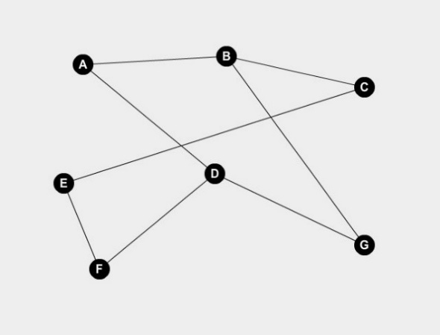

* 1. Prove or disprove that the graph is bipartite.
  2. Verify the handshake theorem.

1. Given the following tree:

* 1. What vertices are adjacent to 5?
  2. What is the degree of vertex 4?
  3. Which vertices are leaves?
  4. What is the height of the tree?
  5. How many internal vertices are there?

Module 3:

1. Solve the following systems of equations:
$\frac{1}{5}x+\frac{2}{5}y=-2y+3x$

$$2x+9=6y$$

$2y-\frac{x+3}{2}=\frac{7}{8}$

$$16y+2x=25$$

2. A rectangular field has the qualities:

* Its width is two-thirds of its length longer than its length (i.e. $w=\frac{2}{3}l+l)$.
* Its perimeter is 3200m.
  1. Find the length of the diagonal line that crosses from the lower left corner to the upper right corner.
  2. Given that John is running clockwise at a speed of 10km/hr. and Abby is running counterclockwise at a speed of 6km/hr. They both leave from the same location at the same time, how much time is need for them to meet up? (Use field from before as distance)
  3. If they run for 12hrs with the same conditions from the previous part, how many times do they pass each other? (Excluding the starting point)

1. Tim Hortons puts 10 Timbits in each box. Once Tim Hortons finishes packaging all their Timbits into those boxes, they found out that they have 3 Timbits left. If they initially had less than 100 Timbits, what is the maximum number of Timbits they could have had before packaging?
2. Solve the following Word Problems:
   1. Three more than half of the number is equal to the product of five and two less than six
   2. One quarter of three more than a number is equal to one less than the product of eight and two
   3. Square root of two more than a number is equal to seven less than four squared

Module 4:

1. Consider the following matrices and compute the following:
$$A= \left[\begin{matrix}4 & 7 & -9 \\ -9 & 15 & -13 \\ -13 & 5 & -15\end{matrix}\right] B=\left[\begin{matrix}-5 & 7 & 12 \\ -4 & -15 & 14 \\ -5 & -8 & 1\end{matrix}\right] C=\left[\begin{matrix}8 & -1 & -8 \\ 15 & -3 & 5 \\ 13 & 7 & -13\end{matrix}\right]$$

2. AC - B
3. 3A + BC
4. Find the inverses of the following matrices:
$P=\left[\begin{matrix}6 & -2 \\ 3 & 5\end{matrix}\right]$

$A=\left[\begin{matrix}8 & 10 & 8 \\ 0 & 10 & 3 \\ 9 & 9 & 3\end{matrix}\right]$

5. Consider the following vectors:

$\vec{a}= \left[\begin{matrix}-1 \\ 2\end{matrix}\right] \vec{b}=\left[\begin{matrix}0 \\ 4\end{matrix}\right] \vec{c}=\left[\begin{matrix}-3 \\ 1\end{matrix}\right]$

1. Draw $\vec{a}$, $\vec{b}$ and $\vec{c}$ on the cartesian plane
2. Find the magnitude of each vector
3. Calculate the angle between each vector (leave the angle as an expression if you cannot simplify it to an exact value). Round your answer to 2 decimal places.
4. Find the angle between $\vec{b}$ and the positive x-axis (leave the angle as an expression if you cannot simplify it to an exact value)
5. Determine the combo matrix obtained by stretching the $\left[\begin{matrix}1 \\ 2\end{matrix}\right]$ by a factor of 3, rotating counterclockwise by 45 degrees, stretching the $\left[\begin{matrix}-2 \\ -1\end{matrix}\right]$ by a factor of 4 and reflecting through the x-axis.
6. Represent the following pseudograph using an adjacency matrix

E

D

C

B

A

1. Find the determinant and the inverse of the coefficient matrix of each of the following systems of linear equations and solve each using the inverse matrix method.
$7x-6y=-2$

$$3x+y=17$$

$3x-6y=5$

$$x-2y=0$$

$2x+3y+z=2$

$$5x-2y+2z=5$$

$$4x+6y+2z=4$$

$9x-2y+z=8$

$$2x-2y+2z=4$$

$$x+y-z=0$$

2. Three customers purchased the following combinations of items from a store:

* Customer A bought 3 pens and 2 erasers for $14
* Customer B bought 2 pens, 1 pencil and 3 erasers for $13
* Customer C bought 1 pen, 2 pencils and 1 eraser for $9

1. Represent the purchase information in matrix form.
2. Determine if a unique price exists for each item that satisfies the quantities purchased and the total cost.
3. Determine the unique price of each item.